Billing address customization

Contents

Objective 2

Prerequisite 2

Module ejection 2

Steps to consume and test the sample code for UX 2

Module 1: custom-account-management-address 3

Module 2: custom-checkout-billing-address 3

Build and test the changes 3

Deployment 4

Steps to configure the modules in CMS 4

Account Management changes for Addressbook 4

Checkout Page configuration 6

HQ Extensions 7

Import the AX package 7

Package and Deployment for RTS extension 7

Attribute Creation 8

Validate the Billing address custom feature. 9

Validate the HQ UI Changes 15

# Objective

The objective is to provide an E2E customization for saving the billing address for the customer with a Sales Order. Today only shipping address is saved.

Below pages will be affected by this customization:

* Checkout Page
* Address book in MyAccount section

# Prerequisite

* SSK Module code need to be deployed and running.

Reference link: <https://docs.microsoft.com/en-us/dynamics365/commerce/e-commerce-extensibility/setup-dev-environment>

# Module ejection

Cloned the account-management-address module and the checkout-billing-address module for this customization.

Ejected those modules and cloned them into *custom-account-management-address* which contains the changes for the MyAccount/addresses flow for billing customization and *custom-checkout-billing-address* module which contains the changes for the checkout flow.

Ref: <https://docs.microsoft.com/en-us/dynamics365/commerce/e-commerce-extensibility/cli-command-reference#clone>

# Steps to consume and test the sample code for UX

Unzip the Billing Address Customization folder to see the files below

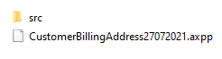

Under src there will be folders

Below are the files that have been changed as part of the module ejection

## Module 1: custom-account-management-address



## Module 2: custom-checkout-billing-address



Supporting files: The files in actions common and themes are required in the ejected modules

* Copy the modules, actions and common folders under src/ folder of the repository.
* Replace the address.scss file with the new file under the folder src/themes/fabrikam/styles
* If there is another customization, for example on checkout, you will need to integrate as needed.

Build and test the changes

Run yarn and yarn build to build the package.

Once you are done with all the above code changes, you are good to go for testing. Execute *yarn build* from command line interface on your repository.

* Execute *yarn start*.
* Browse the local host 4000 port using page mocks with new module types for custom-account-management-address and custom-checkout-billing-address

Example of mock for custom-account-management-address

* A screenshot of a computer

  Description automatically generated with low confidence

*The sample code is tested on below package version: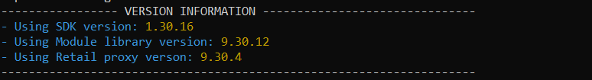

# Deployment

Package deployment is required to configure the changes in the site authoring tool.

Reference for deployment process:

<https://docs.microsoft.com/en-us/dynamics365/commerce/e-commerce-extensibility/package-deploy>

# Steps to configure the modules in CMS

## Account Management changes for Addressbook

Edit marketing template to add new module custom account management address and delete the old module

After editing, click on Save, finish editing and then publish.

Go to the Address book page and remove the old address management module and add the new one

Make the following changes in configuration

Click on save, finish editing and then publish.

## Checkout Page configuration

Edit checkout fragment to add new module Custom checkout billing address and delete the old module Billing Address.

Make the configuration changes below

Click on save, finish editing and then publish.

# HQ Extensions

The Customer Billing Address has been included on the Sales Order form by using the Chain of Commands (COC) and extensions.

TheBilling Address details are collected from the Attribute values Sales order Header / Line level and all the changes are customized/extensions on model Application Suite extensions.

## Import the AX package

The ax package is in the Billing Address Customization folder



Please see instructions on how to import the x++ project.

[**https://docs.microsoft.com/en-us/dynamics365/fin-ops-core/dev-itpro/dev-tools/projects#import-an-axpp-file**](https://docs.microsoft.com/en-us/dynamics365/fin-ops-core/dev-itpro/dev-tools/projects#import-an-axpp-file)

This is the list of files added for extension for the customization.

If there are existing customizations, after importing the project integrate these changes rebuild and create a deployable package.

## Package and Deployment for RTS extension

Documentation on how you can package and deploy the extension:

[**https://docs.microsoft.com/en-us/dynamics365/fin-ops-core/dev-itpro/deployment/create-apply-deployable-package**](https://docs.microsoft.com/en-us/dynamics365/fin-ops-core/dev-itpro/deployment/create-apply-deployable-package)

## Attribute Creation

The following attributes have been created for this customization.

# Validate the Billing address custom feature.

After deploying the modules, AX changes and CMS is configured for the new modules, run validation for an End-to-End Scenario.

1. **Customer profile (My Account > Addresses)**

* Add buttons for shipping address and billing addressGraphical user interface, application, website

  Description automatically generated
* The address under billing address will be of Invoice AddressType.
* On click of **Add address**, customer gets set of fields to add a new address. The AddressType dropdown will be defaulted to Invoice and will be disabled.

**2. Signed-In customer existing Shipping address flow:**

On Checkout, signed in customer gets an option to change the shipping address (as in the original flow)

Here, if the customer clicks the change link, it displays a list of all customer addresses and will also include any newly added invoice address as per current behavior.

* User can add a new address

**2. Customized, checkout signed-In customer billing address flow:**

Billing address flow is customized under Payment method section, like the shipping address functionality

1. Billing Address Section flow
   1. The checkbox for “*same as shipping address*” will be unchecked by default
   2. The default address will be the first address from the customer Addresses having Type as Invoice
   3. If the user selects “*same as shipping address*” checkbox, the shipping address in the delivery section will be added with Address Type as Invoice.
   4. The saved address will be added to my account section under billing address

2. When the user clicks on the save button then it will follow below actions:

1. If the “***Save and Continue button***” is pressed, it will Add Customer Address using Customer Patch call

2. Update selected billing address using cart updateAttributeValues

3. If “*same as shipping address*” is selected and that billing address is not present in Customer’s Address book, then it will get added through Customer Patch call, else it will select from the Customer Address list.

4. After “*Save and Continue*”, “*Change*” link button will appear on the right top section of Payment section. When user clicks on it, a list of the billing addresses will appear under it with “***Add Address***” button.

The user can add a different address here by clicking on the change link for payment section. This address will be used as the billing address for this transaction and will also be saved under the billing addresses in my account section as Invoice addressType

**Checkout Anonymous user billing address flow:**

* 1. This flow remains the same as is
  2. When the user clicks on the save button then it will add billing Address into Cart Attributes and send to the Retail Server using updateAttributeValues

# Validate the HQ UI Changes

When order created on UX, need to store the Billing Address and Shipping Address on Sales order Header and Line level.

1. Billing address should be saved on the customer master

*Account Receivable >> Customers >> All Customers*

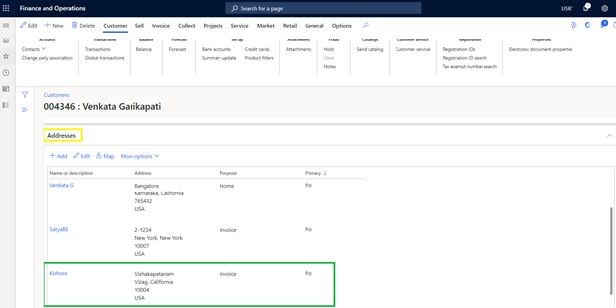

1. Added the Name and Billing Address on Sales order Form

*Account Receivable >> Orders >> All Sales orders >> double click on the selected order.*

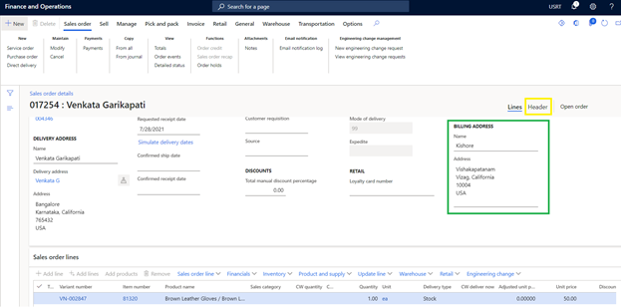

1. Billing Address should appear on Sales order Header >> Address Tab

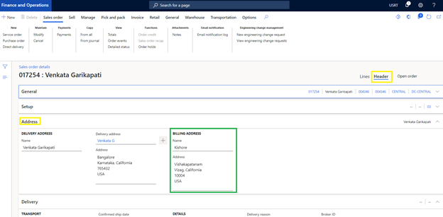

1. Billing Address should appear on the Sales order Line >>Address Tab.

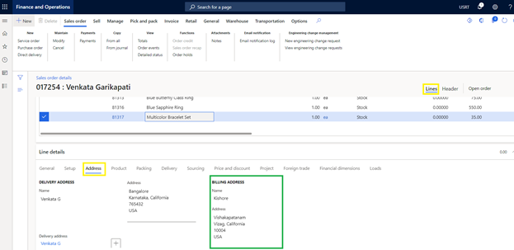

Here Line Billing Address should be the same as the Header Billing Address when the Billing Address is empty on the sales Lines.

**Guest User**:

1. The Billing address for Guest users is not added in Customer Master form in HQ.
2. In HQ Sales order form, the Billing address is shown in Header and line level